SSRS

SLECTING DATASET

THE SELECTED DATASET FOR LOAN OPERATION

REPORT-1 LOAN DATASOURCE-MATRIX METHOD

DESIGNING THE LOAN REPORT

THE ABOVE PICTURE IS THE RESULT OF LOAN DATASET

I HAVE MADE USE OF THE LOAN DATASET TO VERIFY THE SUM OF SBA_GROSS,DISBURSEMENT GROSS AND GRAAPPROV INDIVIDUAL BANKWISE

THE QUERY I HAVE BUILD TO MAKE THIS REPORT

**SELECT** DisbursementGross,SBA_Appv,GrAppv,ApprovalFY,BANK **FROM** FA_LOAN **WHERE** BANK = 'BANK OF AMERICA NATL ASSOC';

REPORT-2

INSURANCE REPORT DATASET

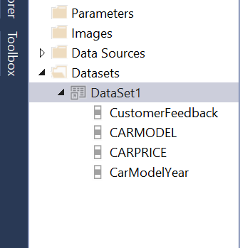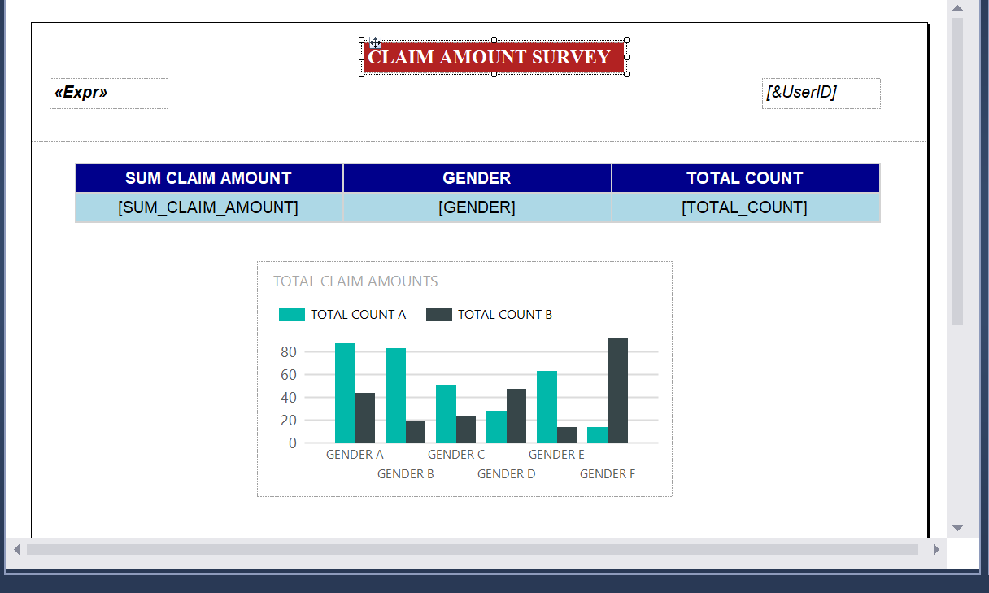

INSURANCE REPORT DESIGNING PART

INSURANCE REPORT RESULT

I HAVE BUILD THE REPORT TO KNOW THE SUM OF CLAIMAMOUNT GENDERWISE WITH THE TOTALCOUNT

REPROT-3

DRILL DOWN REPORT – DATASOURCE = CINEMATICKET

DESIGNING OF DRILL DOWN REPORT

THE MAIN PROCESS WE GOING TO PERFORM IN DRILL DOWN REPORT IS GROUPING

WE NEED TO SELECT THE HIDE OPTION IN THE VISIBILITY AND CHECK THE BELOW COLUMN AND SELECT THE GROUPED COLUMN

REPORT-4 SALES DATASOURCE

DESIGNING PART OF THE SALES

WHERE I HAVE MADE A REPORT TO CHECK THE CUSTOMER FEEBACK ON THE CARS YEARWISE WITH THE CAR MODEL,CAR PRICE

AND EVEN I HAVE GROUPED THE CARS BASED ON THE CUSTOMER FEEDBACK

IN THE ABOVE SCREENSHOT WE CAN SEE THE RESULT OF CUSTOMER FEEDBACK